1. **Write a simple "Hello World" program in two different programming languages of your choice. Compare the structure and syntax.**

**#C language:-**

#include <stdio.h>;

#include <conio.h>;

int main(){

printf("Hello World");

}

**#Java Language:-**

public class Hello{

public static void main(String args[]){

System.out.println(“Hello World”);

}

}

1. **Research and create a diagram of how data is transmitted from a client to a server over the internet.**

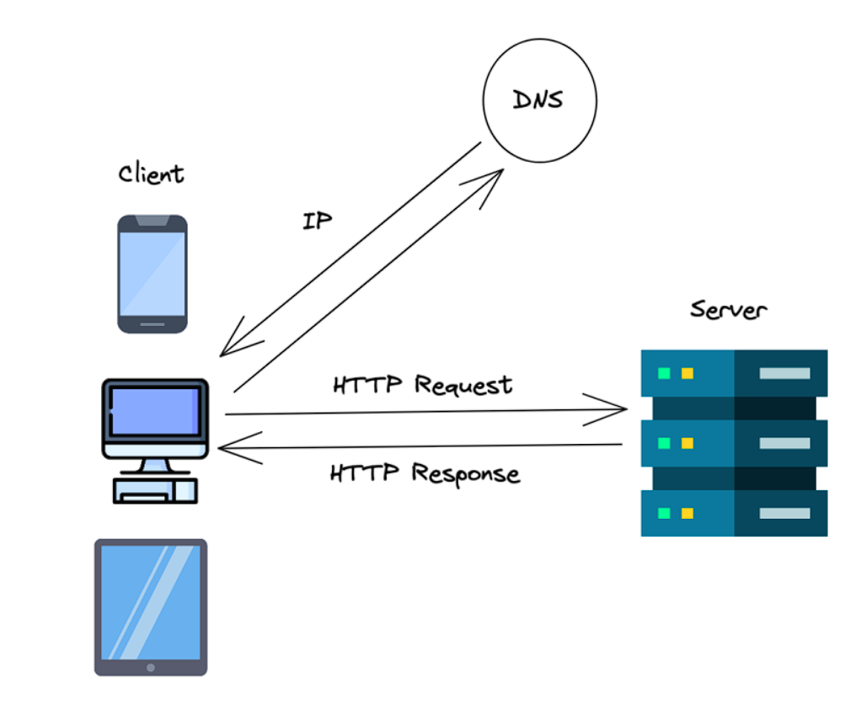

1. **Write and upload your firstsource code file to Github.**

Here are the **steps to write and upload your first source code file to GitHub** using Git:

**Step 1: Create a Simple Source Code File**

Create a simple file named hello.java:

java

CopyEdit

// hello.java

public class Hello {

public static void main(String[] args) {

System.out.println("Hello, GitHub!");

}

}

**Step 2: Set Up Git (If not done yet)**

bash

CopyEdit

git config --global user.name "Your Name"

git config --global user.email "your@email.com"

**Step 3: Create a Local Git Repository**

bash

CopyEdit

mkdir github-demo

cd github-demo

git init

**Step 4: Move Your File into the Repository**

bash

CopyEdit

mv /path/to/hello.java .

git add hello.java

git commit -m "Initial commit - hello.java"

**Step 5: Create a Repository on GitHub**

1. Go to <https://github.com>
2. Click **"New repository"**
3. Name it (e.g., my-first-java)
4. Do **not** initialize with README
5. Click **"Create repository"**

**Step 6: Push to GitHub**

In terminal:

bash

CopyEdit

git remote add origin https://github.com/your-username/my-first-java.git

git branch -M main

git push -u origin main

1. **Design a basic three-tier software architecture diagram for a web application. in 2 to 3lines**

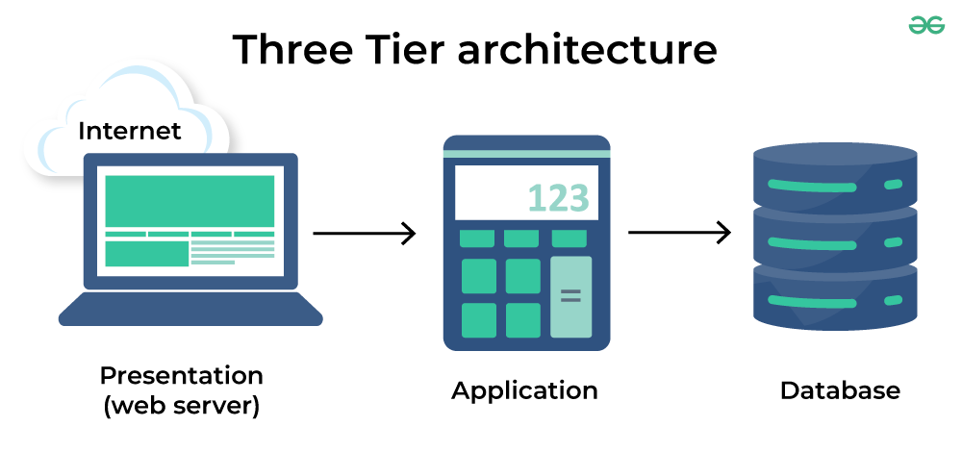

1. **Create a GitHub repository and document how to commit and push code changes.**

**1. Creating a GitHub Repository (Theoretical Steps)**

A **repository** is like a container where all your project files and version history are stored.

**Steps:**

1. **Sign in** to [GitHub](https://github.com).
2. Click on the **“New Repository”** button.
3. **Enter repository details**, such as:
   * Repository name
   * Description (optional)
   * Visibility (public or private)
4. Choose whether to initialize with a **README**, **.gitignore**, or **license** (optional).
5. Click **Create Repository**.

At this point, GitHub creates a repository URL (e.g., https://github.com/username/my-repo.git) which can be used to connect your local project.

**2. Committing Code Changes (Theory)**

A **commit** is like saving a snapshot of your project.

**Commit Workflow (Theory):**

* You **stage** the changes you made using the git add command. This tells Git which changes to include in the next snapshot.
* You **commit** the staged changes using the git commit command. This permanently saves the snapshot with a message explaining the changes.

Think of git add as preparing files for backup, and git commit as actually creating the backup.

**3. Pushing Code to GitHub (Theory)**

**Pushing** is the process of uploading your local commits to GitHub.

**Steps:**

* Use git push to upload committed code to the remote repository.
* The first time you push, you often set the upstream branch using -u origin main or master.

After this, your local code is visible in the GitHub repository and can be shared or collaborated on.

1. **Create a student account on Github and collaborate on a small project**

**With a classmate.**

**o** Sign up at github.com with your email and create a new

account.

o Verify your email and complete your GitHub profile setup.

o Apply for GitHub Student Pack at education.github.com.

o Create a new repository for your project from your GitHub

dashboard.

o Initialize the repository with a README file and choose

visibility (public/private).

o Add your classmate as a collaborator under Settings >

Collaborators.

o Clone the repository to your local system using git clone

<repo_url>.

o Work on the project locally and commit changes using git add.,

git commit -m "", and git push.

o Your classmate can pull changes, add their contributions, and

push updates.

o Use GitHub issues or pull requests to manage tasks and collaborate effectively.

1. **Follow a GIT tutorial to practice cloning, branching, and merging**

**repositories.**

**o** Install Git from git-scm.com and set up your username and email using

git config.

o Clone a repository using git clone <repository_URL>.

o Navigate into the project folder with cd <repo_name>.

o Create a new branch using git checkout -b <branch_name>.

o Make changes to files and stage them using git add ...

o Commit the changes using git commit -m "Your message".

o Switch back to the main branch using git checkout main.

o Merge your branch into main using git merge <branch_name>.

o Push changes to GitHub with git push origin main.

o Delete the feature branch if needed using git branch -d <branch_name>.

1. **Create a flowchart of Software Development Lifecycle (SDLC).**

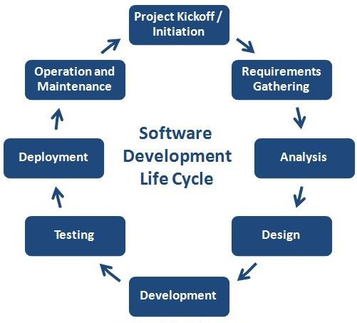

1. **Design a basic system architecture for a food delivery app**

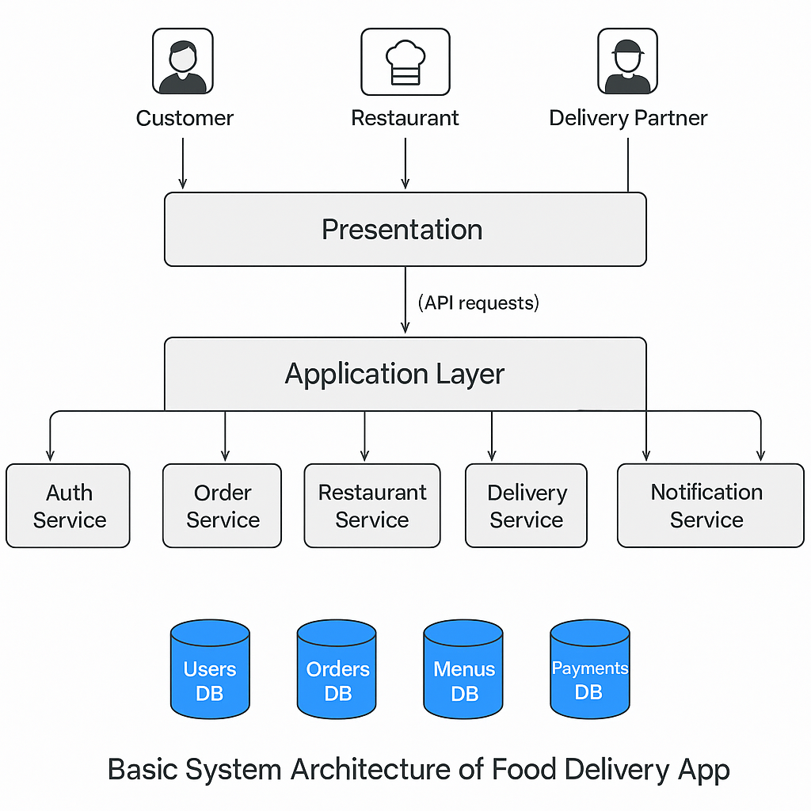

1. **Develop test cases for a simple calculator program.**

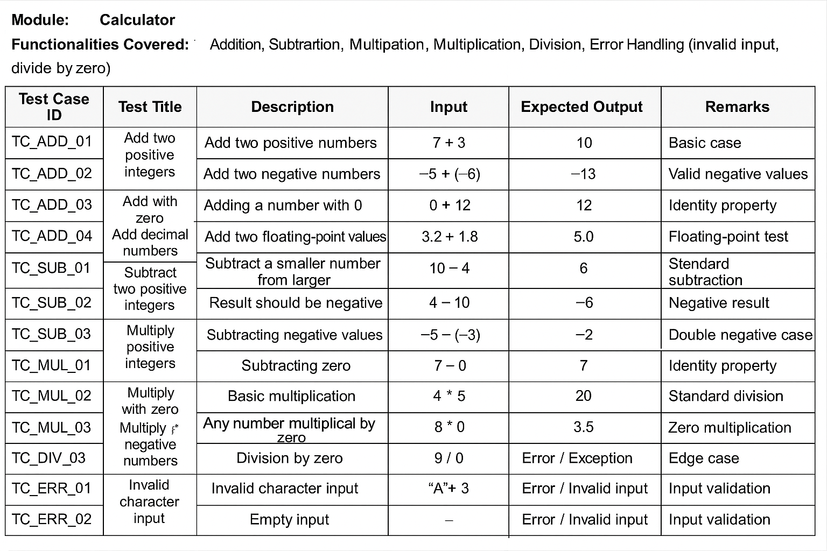

1. .**Create a DFD for a hospital management system.**

Draw a flowchart representing the logic of a basic online registration system.



1. **Draw a flowchart representing the logic of a basic online registration system.**

